

**AROR UNIVERSITY OF ART ARCHITECTUR DESIGN AND HERITAGE SUKKUR**

**Lab 05**

**TASK 01**

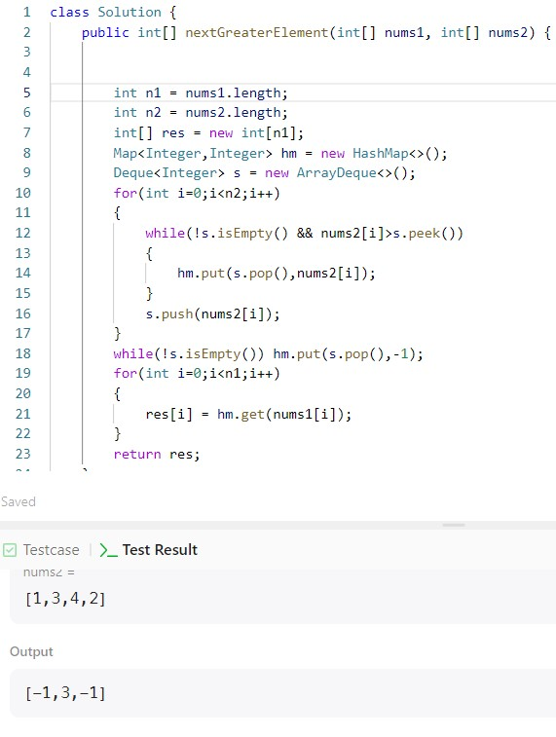

**TASK 02**

**TASK 03**

